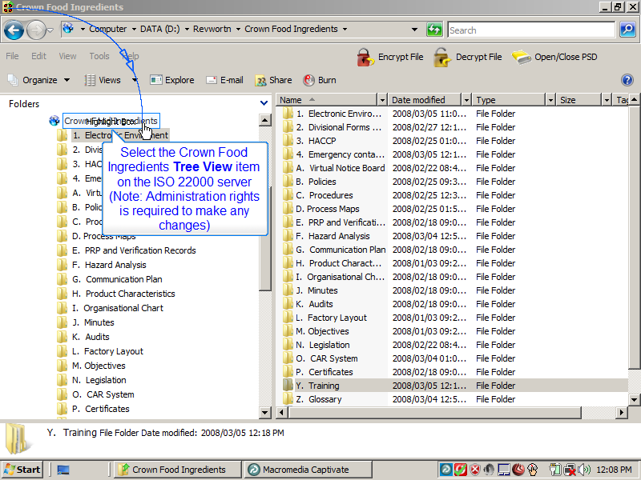
Slide 1
Note:
Select the Crown Food Ingredients Tree View item on the ISO 22000 server
(Note: Administration rights is required to make any changes)
Notes:

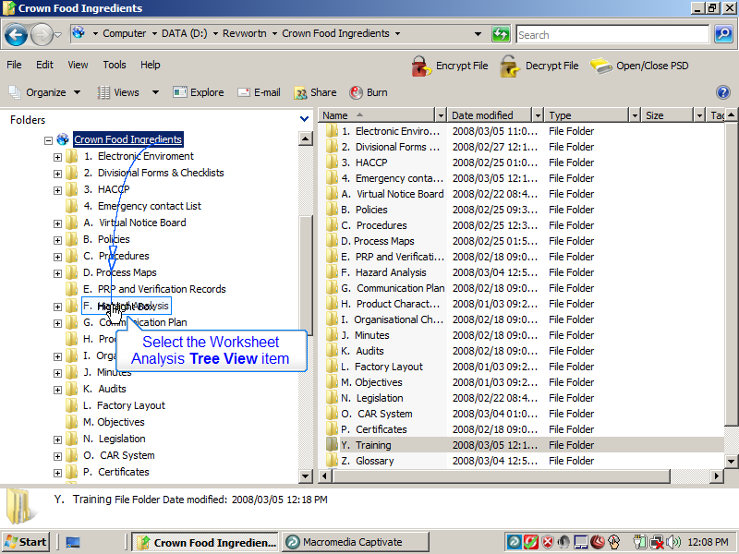
Slide 2
Note:
Select the Worksheet Analysis Tree View item
Notes:

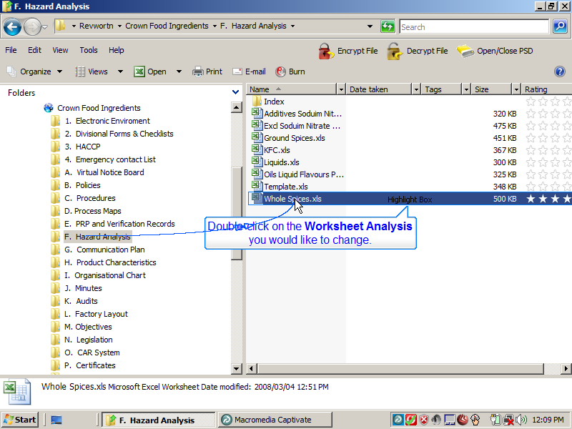
Slide 3
Note:
Double-click on the Worksheet Analysis you would like to change.
Notes:

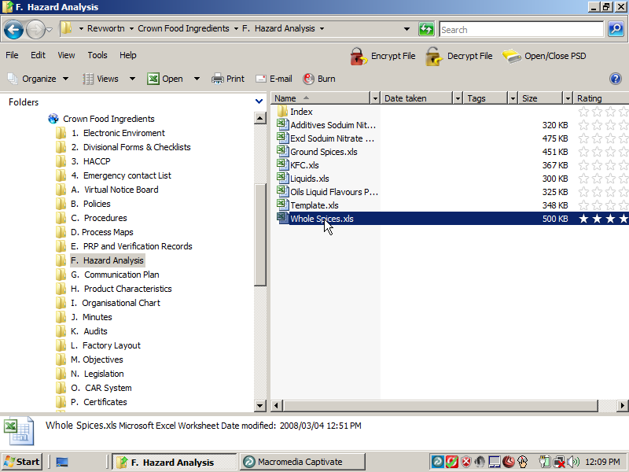
Slide 4
Note:
Notes:

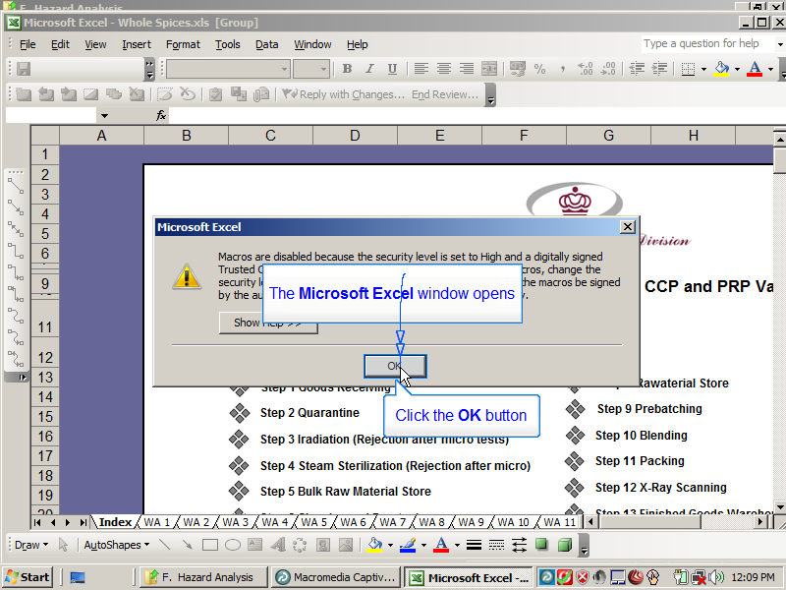
Slide 5
Note:
The Microsoft Excel window opens
Click the OK button
Notes:

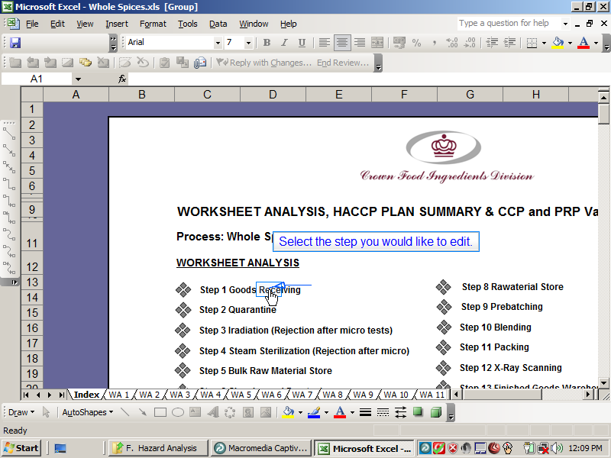
Slide 6
Note:
Select the step you would like to edit.
Notes:

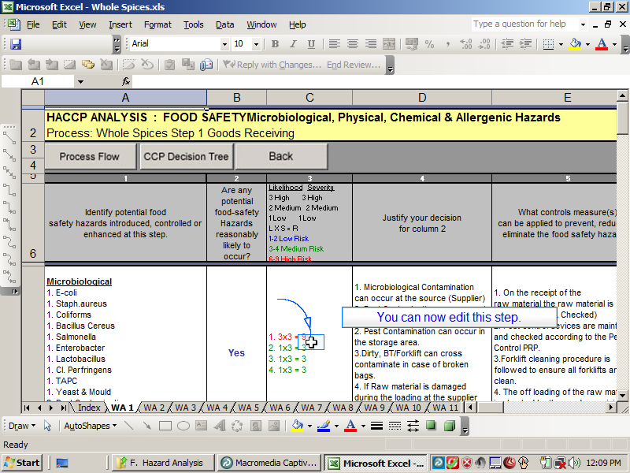
Slide 7
Note:
You can now edit this step.
Notes:

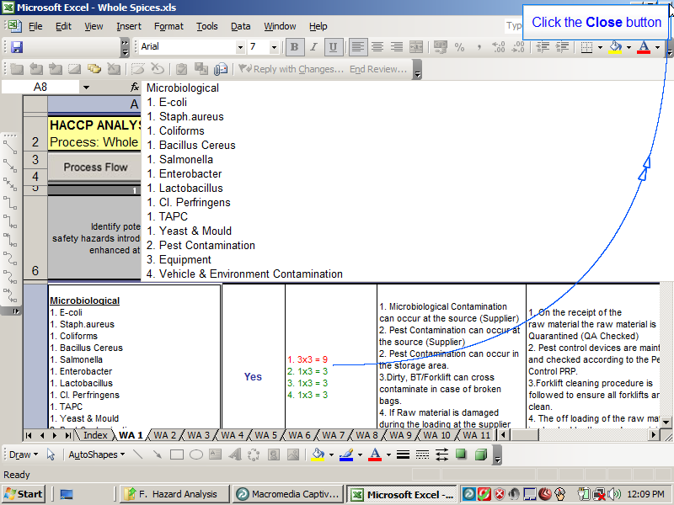
Slide 8
Note:
Click the Close button
Notes:

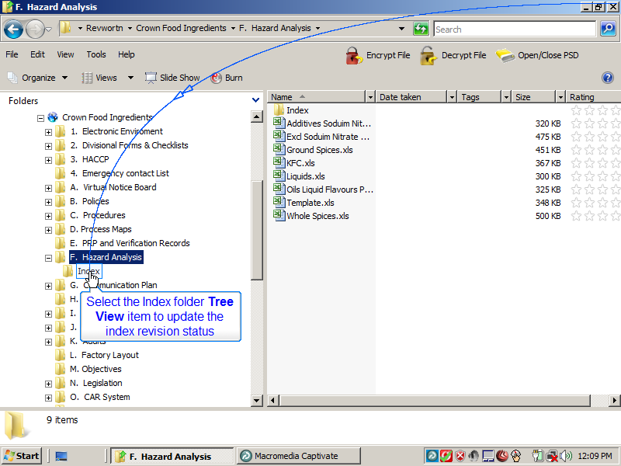
Slide 9
Note:
Select the Index folder Tree View item to update the index revision status
Notes:

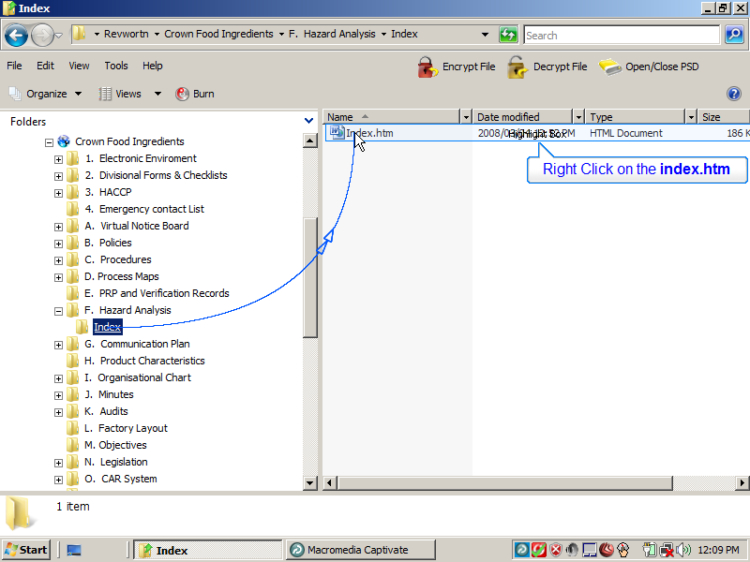
Slide 10
Note:
Right Click on the index.htm
Notes:

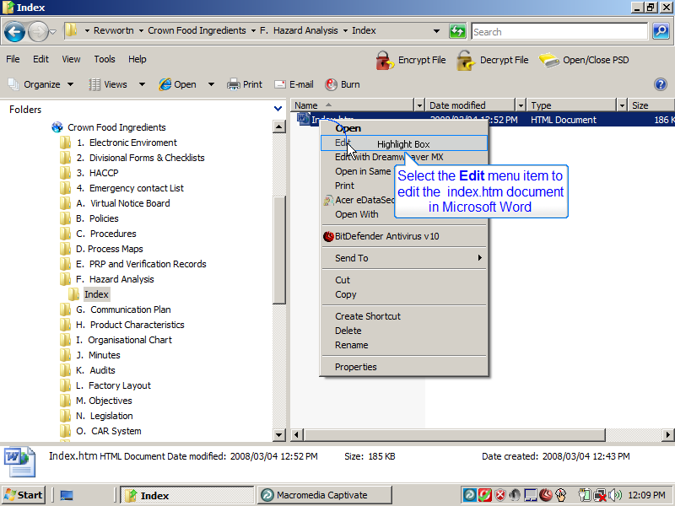
Slide 11
Note:
Select the Edit menu item to edit the index.htm document in Microsoft Word
Notes:

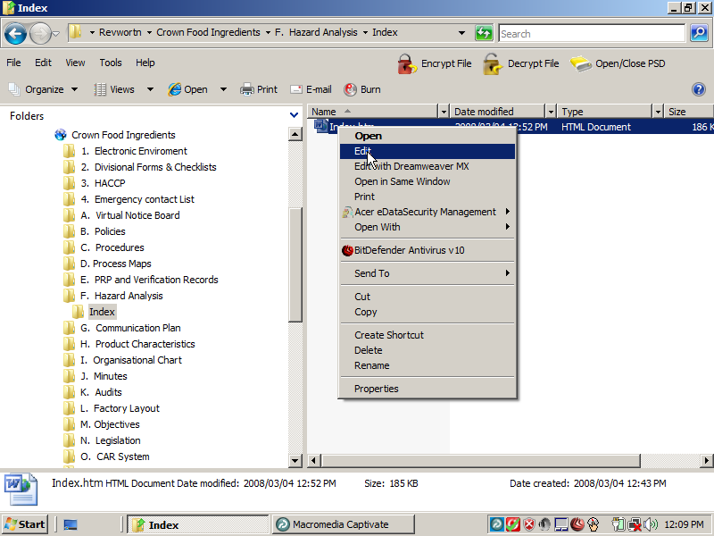
Slide 12
Note:
Notes:

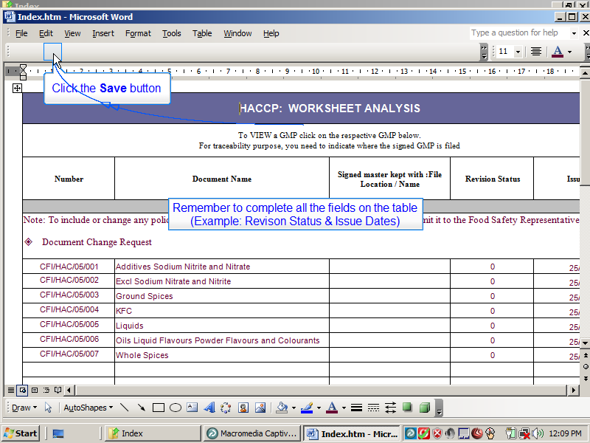
Slide 13
Note:
Remember to complete all the fields on the table
(Example: Revision Status & Issue Dates)
Click the Save button
Notes:

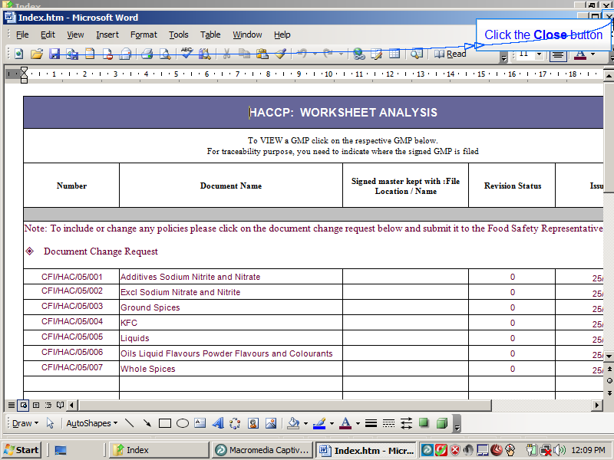
Slide 14
Note:
Click the Close button
Notes:

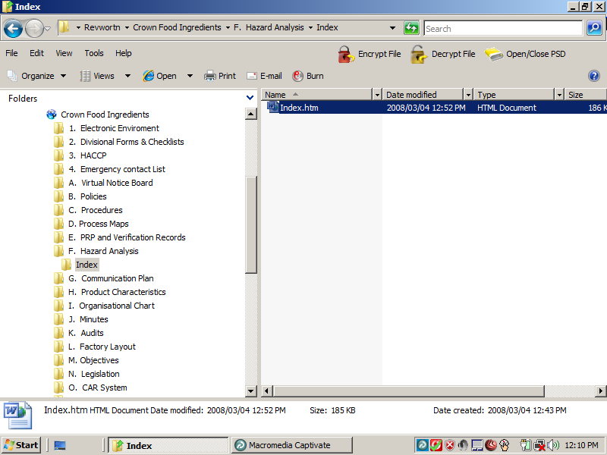
Slide 15
Note:
Notes:

